
Created on : 04 – March - 2023

Change Data Capture
Using
Informatica IICS Microsoft SQL Server CDC Connector

Contents
1 Contents 2
2 Microsoft SQL Server CDC Connector usage scenario 3
3 Introduction to Microsoft SQL Server CDC Connector 3
4 Integration with the PowerExchange CDC environment 4
5 Configuring The CDC Environment 5
5.1 Software requirements 5
5.2 Steps for configuration CDC 7
5.2.1 Make the Database that contains tables as transactional 7
5.2.2 Install the Power Exchange where the SQL server is installed 8
Step 3. Verify or Set the Path Environment Variable 9
5.2.3 Change the Dbmover and PWXCCL file 10
5.2.4 Start the PWX Listener 14
5.2.5 Start the PWX Logger 14
5.2.6 Install the PWX Navigator in separate window machine 14
5.2.7 Configure CDC table in Navigator 15
5.2.8 Build the Mapping 18

Microsoft SQL Server CDC Connector usage scenario
Your organization needs to replicate change data in real time from a mission-critical Microsoft SQL Server production system to minimize intrusive, non-critical work, such as offline reporting or analytical operations, on that system.You can use SQL Server CDC Connector to connect to an on-premises PowerExchange CDC system from another Linux or Windows system where the Secure Agent is installed. SQL Server CDC Connector components retrieve metadata about SQL Server source tables and the change records that PowerExchange captured for these sources.

The source metadata is stored in the Data Integration cloud. You can use the browser-based Informatica Intelligent Cloud Services interfaces to define SQL Server CDC connections, mappings, and mapping tasks. When you run the mapping tasks, SQL Server CDC Connector components in conjunction with Data Integration retrieve and process the change records that PowerExchange captured from the production database and transmit these change records to one or more targets. Multiple users can then access the latest data on the target systems.

By using SQL Server CDC Connector, you reduce the workload on the SQL Server production systems while making accurate and up-to-date SQL Server change data available to multiple users on less critical target systems. Also, you gain access to easy-to-use, browser-based interfaces for defining mappings and mapping tasks and running and monitoring mapping tasks.

Introduction to Microsoft SQL Server CDC Connector

You can use Microsoft SQL Server CDC Connector to connect to a PowerExchange for Microsoft SQL Server change data capture (CDC) environment to retrieve change records for SQL Server source tables. PowerExchange captures change records from the SQL Server distribution database and logs the change records in PowerExchange Logger for Linux, UNIX, and Windows log files. SQL Server CDC Connector extracts the change records from PowerExchange Logger log files and sends the change records to Data Integration. Data Integration can then transmit the change records to a supported target.

When you define mappings in Data Integration, you select the extraction maps that PowerExchange generated for SQL Server source tables when you registered the tables. The SQL Server CDC Connector metadata adapter can then retrieve the source metadata from the extraction maps and store this information in the cloud.

To extract source change records from PowerExchange Logger log files, you must run the mapping tasks that are associated with the mappings. A mapping task runs to the end-of-log (EOL) in the PowerExchange Logger log files and then stops. You can manually restart the mapping task from a specific point in the logs, create a schedule that runs the mapping task on a recurring basis, or run the mapping task continuously. If the mapping task fails, SQL Server CDC Connector can resume processing from the point of interruption based on recovery information that is stored on the target.

SQL Server CDC Connector must be able to connect to an active PowerExchange change capture environment that includes the PowerExchange Logger. You do not need to copy the PowerExchange dbmover configuration file or PowerExchange Logger pwxccl configuration file to the SQL Server CDC Connector system. For more information about configuring PowerExchange for SQL Server CDC and the PowerExchange Logger, see the PowerExchange CDC Guide for Linux, UNIX, and Windows.

SQL Server CDC Connector works with the Informatica Cloud Secure Agent. When you install and start the Secure Agent, it downloads the SQL Server CDC Connector components and PowerExchangeClient packages. When you define a runtime environment, you configure a Secure Agent group.

Integration with the PowerExchange CDC environment
You must have a functional on-premises PowerExchange CDC for Microsoft SQL Server environment that captures change records for source tables from the SQL Server distribution database and logs the changes to PowerExchange Logger for Linux, UNIX, and Windows log files. Also, you must have a license that allows your organization to use the SQL Server CDC Connector and PowerExchangeClient packages on Linux or Windows.On each system from which you plan to use the SQL Server CDC Connector, you must install the Secure Agent. After you start the Secure Agent the first time, the SQL Server CDC Connector and PowerExchangeClient components are installed locally. You then can use Cloud Data Integration, Administrator, and Monitor interfaces to configure SQL Server CDC connections, mappings, and mapping tasks and to run and monitor mapping tasks.

In this configuration, the PowerExchange change capture environment resides on one Windows system and the SQL Server CDC Connector environment resides on another Linux or Windows system. The PowerExchange Navigator runs on a Windows system apart from both environments. Based on this image, the following processing occurs:

1.PowerExchange actively captures change records from the Microsoft SQL Server distribution database and sends the records to the PowerExchange Logger for Linux, UNIX, and Windows on a continuous basis.To capture change records, the PowerExchange uses the capture registrations and extractions maps that you defined in the PowerExchange Navigator for the SQL Server source tables.

2.The PowerExchange Logger logs the change records in its log files.The PowerExchange Logger configuration is defined by the pwxccl.cfg configuration file.

3. When you design a mapping in Data Integration, you associate the Source transformation with a SQL Server CDC connection. You can define the connection in either Data Integration or Administrator. The PWX CDC Metadata Adapter then uses the SQL Server CDC connection to connect to the PowerExchange Listener and retrieve extraction-map metadata for the SQL Server source from the PowerExchange CAMAPS file.
In the mapping, you must also define a Target transformation and connection and map the source fields to target fields.

4. The Secure Agent in conjunction with Data Integration sends the extraction-map metadata to the Informatica Intelligent Cloud Services repository in the cloud.

5.When you run the mapping task that is associated with the mapping, all of the CDC metadata, connection properties, mapping information, advanced source properties, CDC runtime properties, and advanced session properties are pushed down to the on-premises Secure Agent in the form of a session .xml file.

6.The PWX CDC Reader on the Secure Agent machine communicates with the PowerExchange Listener to retrieve the change records from PowerExchange Logger log files.

7.Data Integration transmits the change records to the mapped target.

Alternative configurations of PowerExchange with the SQL Server CDC Connector components and Cloud Data Integration are possible. For example:
• The PowerExchange change capture process, PowerExchange Logger, SQL Server source, SQL Server CDC Connector components, and Secure Agent can all run on the same Windows system.
•The PowerExchange Logger for Linux, UNIX, and Windows and its log files can reside on a system that is remote from the SQL Server source system and remote from the Linux or Windows system where the SQL Server CDC Connector components and Secure Agent run. Logging change data to a remote Logger can reduce resource consumption on the source system and possibly reduce the network overhead of data transfer. For more information, see "Remote Logging of Data" in the PowerExchange CDC Guide for Linux, Unix, and Windows.
•The PowerExchange Navigator can run on any supported

Configuring The CDC Environment
Following are the software those are required for CDC
- Power Exchange Software (10.5.x are the latest )
- IICS CDC SQL connector
- SQL server
- Separate system for Navigator
- Secured Agent In separate machine ( Windows / Linux )

Software requirements

Power Exchange Software

You must have a local or remote PowerExchange installation. The following PowerExchange versions are supported:
-
PowerExchange 10.5.x
-
PowerExchange 10.4.1
-
PowerExchange 10.4.0 HotFix 1
-
PowerExchange 10.4.0

PowerExchange supports the following Windows versions on 64-bit Opteron and EM64T Windows machines for bulk data movement and CDC:
- Windows 2022
- Windows 2019
- Windows 2016

Microsoft SQL Server CDC Connector

Product Availability Matrix (PAM) for Informatica Intelligent Cloud Services (IICS) <current_version>, which is available on Informatica Network at https://network.informatica.com/community/informatica-network/product-availability-matrices

Microsoft SQL Server

Data Source or Target | Data Source or Target Versions | Bulk | CDC
Microsoft SQL Server | 2019  2017  2016  2014 SP2  ²  2012 SP4  ² | X | X (sources only)
MySQL Enterprise Edition has been certified with the Informatica-packaged DataDirect ODBC driver for MySQL. Community Edition has been certified with the MySQL native ODBC driver, which is not shipped with PowerExchange CDC.

PowerExchange Navigator

The following Windows versions, 64-bit only, are supported on machines where the PowerExchange Navigator runs:
- Windows 2022
- Windows 2019
- Windows 2016
- Windows 11
- Windows 10

Steps for configuration CDC

- Make the Database that contains tables as transactional ( Publisher option in replication section of Database
- Install the Power exchange where the SQL server DB is installed
- Change the Dbmover and PWXCCL configuration file
- Start the Listener
- Start the Logger
- Install the PWX Navigator in separate windows machine
- Configure the CDC table in the navigator
- Configure the IICS CDC connection
- Create CDC mapping

Make the Database that contains tables as transactional

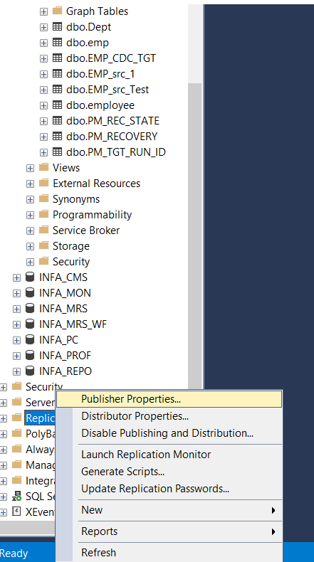
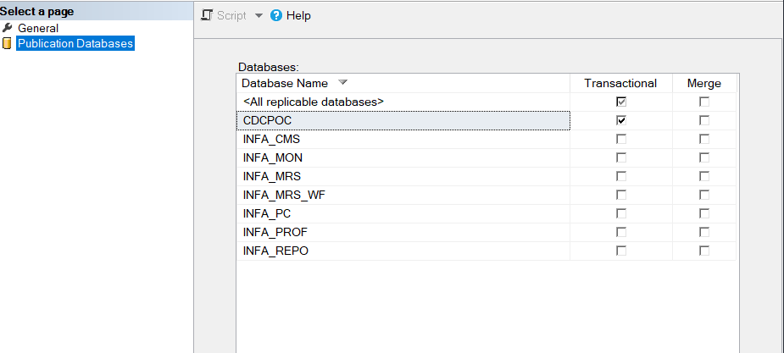

Install the Power Exchange where the SQL server is installed

Use the zip file that PowerExchange provides to install the PowerExchange software on Windows and add the PowerExchange Listener as a Windows service. The zip file is located in the
software/windows
directory of the CD image.
To install PowerExchange on a Windows 32-bit or 64-bit system:
- Extract the contents of the zip file for your Windows platform to a temporary folder.
The zip file is named pwx
vrm
_win_x64.zip. The variable
vrm
is the PowerExchange version, release, and modification level.
PowerExchange versions with integrated hotfix updates have a different format of file name than the base version of the software. For more information about the exact file names, see the
PowerExchange Release Notes
for the PowerExchange hotfix.
When you extract the contents of the zip file, preserve its structure, so that the destination folder includes the following folders and files:
  - properties folder
  - Server folder
  - source folder
  - install.bat file
- Run install.bat.
The installation interface starts.
- If you are prompted to select a language, select a language and click
OK
.
- On the
Introduction
page, click
Next
.
- On the
Enter License Key
page, enter the license key and click
Next
.
If you do not know your license key, see PowerExchange License Keys.
- On the
Installation Directory
page, accept the default installation directory, or click
Choose
to browse to an installation directory.
If you do not want to install the PowerExchange Navigator, clear the check box.
Then click
Next
.
- On the
Pre-Installation Summary
page, review the installation information. If the information is correct, click
Install
.
- On the
Post-Installation Summary
page, click
Done
.

Step 3. Verify or Set the Path Environment Variable
Verify or set the Path environment variable. The installation program updates the Path environment variable to include the PowerExchange installation directory. If the PowerExchange installation directory is not included, PowerExchange features, such as the PowerExchange Navigator help, might not work.
- Click
Start
Control Plan
System
Advanced System Settings
.
- Click
Environment Variables
.
- To verify or change the Path environment variable, perform the following steps:
  - In the
System variables
box, select
Path
and click
Edit
.
  - In the
Variable value
box, verify that the Path environment variable contains the correct path to the PowerExchange installation directory. If it does not, add the PowerExchange installation directory to the semicolon-separated list of paths. If you accepted the default installation location, use the following default path:
C:\Informatica\PowerExchangev.r.m
- Click
OK
- Click
OK

Change the Dbmover and PWXCCL file

Sample as below for SQL server
Dbmover.cfg
/********************************************************************/
/* PowerExchange Dbmover.dfg Configuration File
/********************************************************************/
LISTENER=(node1,TCPIP,2480,262144,262144,262144,262144)
NODE=(local,TCPIP,127.0.0.1,2480)
NODE=(node1,TCPIP,127.0.0.1,2480,262144,262144,262144,262144)
NODE=(default,TCPIP,x,2480)
APPBUFSIZE=256000
COLON=:
CONSOLE_TRACE=N
DECPOINT=.
DEFAULTCHAR=*
DEFAULTDATE=19800101
MAXTASKS=30
MSGPREFIX=PWX
NEGSIGN=-
PIPE=|
POLLTIME=1000
PRE861_COMPAT=N
EXT_CP_SUPPT=Y

/* activate changed data propagation from MSSQL
/* CAPI_CONN_NAME=CAPIMSQ
CAPI_CONNECTION=(NAME=CAPIMSQ,
TYPE=(MSQL,DISTSRV=EC2AMAZ-EPBEL4U,
DISTDB=distribution,
EOF=N,RSTRADV=0))

CAPI_CONNECTION=(NAME=CAPICAPX,TYPE=(CAPX,DFLTINST=PWX_00,FILEWAIT=60,RSTRADV=60,NOSEQVAL=N))

/* Commented sample CAPT_PATH and CAPT_XTRA for Windows when using
/* change data propagation
CAPT_PATH=C:\PWexchange\LG
CAPT_XTRA=C:\PWexchange\LG

/* sample LOGPATH for Windows LOGPATH=C:\informatica\pwx\
LOGPATH=C:\PWexchange\LG

SVCNODE=(node1,8500)
CMDNODE=(node1,LISTENER,127.0.0.1,8500)

SVCNODE=(PwxCons,22480)
CMDNODE=(PwxCons,CONDENSE,127.0.0.1,22480)

/* see Message Log Options in PWX Reference Manual
TRACING=(PFX=ALT,FLUSH=10,FILENUM=99,VIEW=Y,APPEND=Y,SIZE=100,RECLEN=255)

Pwxccl.cfg file

/***************************************************************
/* PowerExchange PWXCCL Configuration File
/***************************************************************

CONDENSENAME=PwxCons
DB_TYPE=MSS
/* DBID must match DFLTINST in DBMOVER.CFG
/* DBID & DFLTINST must match instance name in PWX Navigator!
DBID=PWX_00
/* CAPTURE_NODE_UID (logon) and CAPTURE_NODE_PWD (Password)to connect to MS-SQL Server
CAPTURE_NODE_UID=sa
CAPTURE_NODE_PWD= Give the password
/* CAPTURE_NODE_EPWD for Encrypted Password - if use this, don't use CAPTURE_NODE_PWD
/* CAPTURE_NODE_EPWD=xxxxxxxx
/* CONN_OVR must point to TYPE=MSQL CAPI_CONNECTION in DBMOVER.CFG
CONN_OVR=CAPIMSQ
/* EXT_CAPT_MASK - where to store CND files, and first node of name
/* You have to create the "CAPTURE" directory!
EXT_CAPT_MASK=C:\PWexchange\CONDENSE\CondenseS
/* how long to retain CDCT entries and CND files in days
COND_CDCT_RET_P=7
/* COLL_END_LOG 0==Continuous capture (normal) 1==batch capture
COLL_END_LOG=0
/* For PWX 8.6.1, NDW should always be 1
/* For PWX 9.x, NDW may be be 0
NO_DATA_WAIT=1
/* For PWX 8.6.1, NDW2 should be 60 less than FSV in seconds
/* For PWX 9.x, NDW2 should be the same as FFV (not FSV)
NO_DATA_WAIT2=10
/* FFV in seconds, should be set to customer latency requirements
FILE_FLUSH_VAL=10
/* FSC=M (minutes) FSC=R (records)
FILE_SWITCH_CRIT=M
/* FSV in minutes (FSC=M) or records (FSC=R)
FILE_SWITCH_VAL=10
/* CAPT_IMAGE: AI=AfterImageOnly BA=BeforeAndAfterImage
CAPT_IMAGE=BA
/* VERBOSE logging prints more stats
VERBOSE=N
/* Overrides for Cold Start / Special Start
/* Ignored on Warm Start
SEQUENCE_TOKEN=0
RESTART_TOKEN=0
/**************************************************************

Template for DBMOVER and PWCXCCL file

Example DBMOVER.CFG file.
/***************************************************************
/* PowerExchange Configuration File
/***************************************************************
/* CONFIG: PWXCCL with SQL Server source
/***************************************************************
/* NOTE: Do Not Increase the lengths of the AAAAAAAAAAAA,
/* BBBBBBBB, CCCCCCCCCCCC, and xxxxEEEE strings.
/***************************************************************
/* REPLACE THESE STRINGS:
/* AAAAAAAAAAAA the name of the PWX Listener
/* (will also use this for Listener commands)
/* BBBBBBBB the "Instance" name from PWX Navigator!
/* CCCCCCCCCCCC the name of the PWX Logger
/* (will also use this for Logger commands)
/* DDDDDDDDDD the name of the Distribution Server
/* PWX_HOME the actual directory path for PWX install
/* CAPT_PATH_DIR the path where you want the CCT, CDCT, CDEP
/* CAPT_XTRA_DIR the path where you want extraction maps
/***************************************************************
/* YOU CAN CHOOSE TO REPLACE THESE STRINGS:
/* MSQLEEEE the name of the MSQL CAPI_CONNECTION
/* CAPXEEEE the name of the CAPX CAPI_CONNECTION
/***************************************************************
LISTENER=(AAAAAAAAAAAA,TCPIP,2480)
NODE=(local,TCPIP,127.0.0.1,2480)
NODE=(AAAAAAAAAAAA,TCPIP,127.0.0.1,2480)
NODE=(default,TCPIP,x,2480)
/* SVC & CMD node for Listener (dtllst)
SVCNODE=(AAAAAAAAAAAA,12480)
CMDNODE=(AAAAAAAAAAAA,LISTENER,127.0.0.1,12480)
/* SVC & CMD node for Logger (pwxccl)
SVCNODE=(CCCCCCCCCCCC,22480)
CMDNODE=(CCCCCCCCCCCC,CONDENSE,127.0.0.1,22480)
/*
APPBUFSIZE=256000
COLON=:
COMPRESS=Y
CONSOLE_TRACE=Y
DECPOINT=.
DEFAULTCHAR=*
DEFAULTDATE=19800101
MAXTASKS=5
MSGPREFIX=PWX
NEGSIGN=-
PIPE=|
POLLTIME=1000
/* You have to create the "CAPT_PATH_DIR" directory!
CAPT_PATH=PWX_HOME\CAPT_PATH_DIR
/* You have to create the "CAPT_XTRA_DIR" directory!
CAPT_XTRA=PWX_HOME\CAPT_XTRA_DIR
/* LOGPATH is where startup log messages go
LOGPATH=PWX_HOME\LOGS
/* LOGPATH/PFX is where individual component logs go
/* see Message Log Options in PWX Reference Manual
TRACING=(PFX=ALT,FLUSH=10,FILENUM=99,VIEW=Y,APPEND=Y,SIZE=100,RECLEN=255)
/**************************************************************
/* MS SQLServer capture & extract
/**************************************************************
/* CONN_NAME default - set to CAPX for extract sessions
CAPI_CONN_NAME=CAPXEEEE
/* TYPE=MSQL for MS SQL Server Capture
CAPI_CONNECTION=(NAME=MSQLEEEE,TYPE=(MSQL,
DISTSRV=DDDDDDDDDD,
DISTDB=distribution,
MULTIPUB=N,
/* DWFLAGS=,
MEMCACHE=65535))
/* TYPE=CAPX for Extract
/* DFLTINST must match instance name in PWX Navigator!
/* DFLTINST must also match DBID in PWXCCL.CFG!
CAPI_CONNECTION=(NAME=CAPXEEEE,TYPE=(CAPX,DFLTINST=BBBBBBBB))
/**************************************************************
Example PWXCCL.CFG file.
/***************************************************************
/* PowerExchange PWXCCL Configuration File
/***************************************************************
/* CONFIG: PWXCCL with SQL Server source
/***************************************************************
/* REPLACE THESE STRINGS:
/* BBBBBBBB the DFLTINST name used in DBMOVER.CFG
/* CCCCCCCCCCCC the PWX Logger name used in DBMOVER.CFG
/* PWX_HOME the actual directory path for PWX Install
/* CONDENSE the subdirectory for CND and Checkpoint files
/***************************************************************
/* YOU CAN CHOOSE TO REPLACE THIS STRING:
/* MSQLEEEE the name of the TYPE=MSQL CAPI_CONNECTION
/* from DBMOVER.CFG
/***************************************************************
CONDENSENAME=CCCCCCCCCCCC
DB_TYPE=MSS
/* DBID must match DFLTINST in DBMOVER.CFG
/* DBID & DFLTINST must match instance name in PWX Navigator!
DBID=BBBBBBBB
/* CAPTURE_NODE_UID (logon) and CAPTURE_NODE_PWD (Password)to connect to MS-SQL Server
CAPTURE_NODE_UID=sa
CAPTURE_NODE_PWD=sa
/* CAPTURE_NODE_EPWD for Encrypted Password - if use this, don't use CAPTURE_NODE_PWD
/* CAPTURE_NODE_EPWD=xxxxxxxx
/* CONN_OVR must point to TYPE=MSQL CAPI_CONNECTION in DBMOVER.CFG
CONN_OVR=MSQLEEEE
/* EXT_CAPT_MASK - where to store CND files, and first node of name
/* You have to create the "CAPTURE" directory!
EXT_CAPT_MASK=PWX_HOME\CONDENSE\CondenseS
/* how long to retain CDCT entries and CND files in days
COND_CDCT_RET_P=7
/* COLL_END_LOG 0==Continuous capture (normal) 1==batch capture
COLL_END_LOG=0
/* For PWX 8.6.1, NDW should always be 1
/* For PWX 9.x, NDW may be be 0
NO_DATA_WAIT=1
/* For PWX 8.6.1, NDW2 should be 60 less than FSV in seconds
/* For PWX 9.x, NDW2 should be the same as FFV (not FSV)
NO_DATA_WAIT2=10
/* FFV in seconds, should be set to customer latency requirements
FILE_FLUSH_VAL=10
/* FSC=M (minutes) FSC=R (records)
FILE_SWITCH_CRIT=M
/* FSV in minutes (FSC=M) or records (FSC=R)
FILE_SWITCH_VAL=10
/* CAPT_IMAGE: AI=AfterImageOnly BA=BeforeAndAfterImage
CAPT_IMAGE=BA
/* VERBOSE logging prints more stats
VERBOSE=Y
/* Overrides for Cold Start / Special Start
/* Ignored on Warm Start
SEQUENCE_TOKEN=0
RESTART_TOKEN=0
/**************************************************************

Start the PWX Listener

dtllstsi start node1

Start the PWX Logger

pwxccl coldstart=Y config=C:\PWexchange\dbmover.cfg cs=C:\PWexchange\pwxccl.cfg

Install the PWX Navigator in separate window machine

- Install the navigator in separate machine.
- Copy the dbmover and pwxccl configuration file to the machine

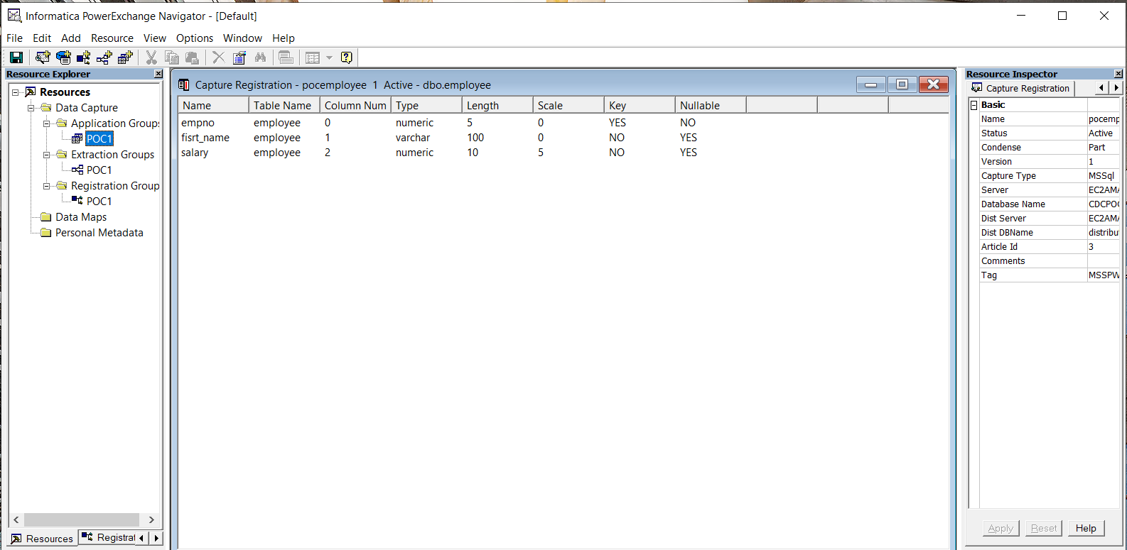

Configure CDC table in Navigator

Reference will be taken from sample dbmover.cfg to explain the below settings
Add registration group

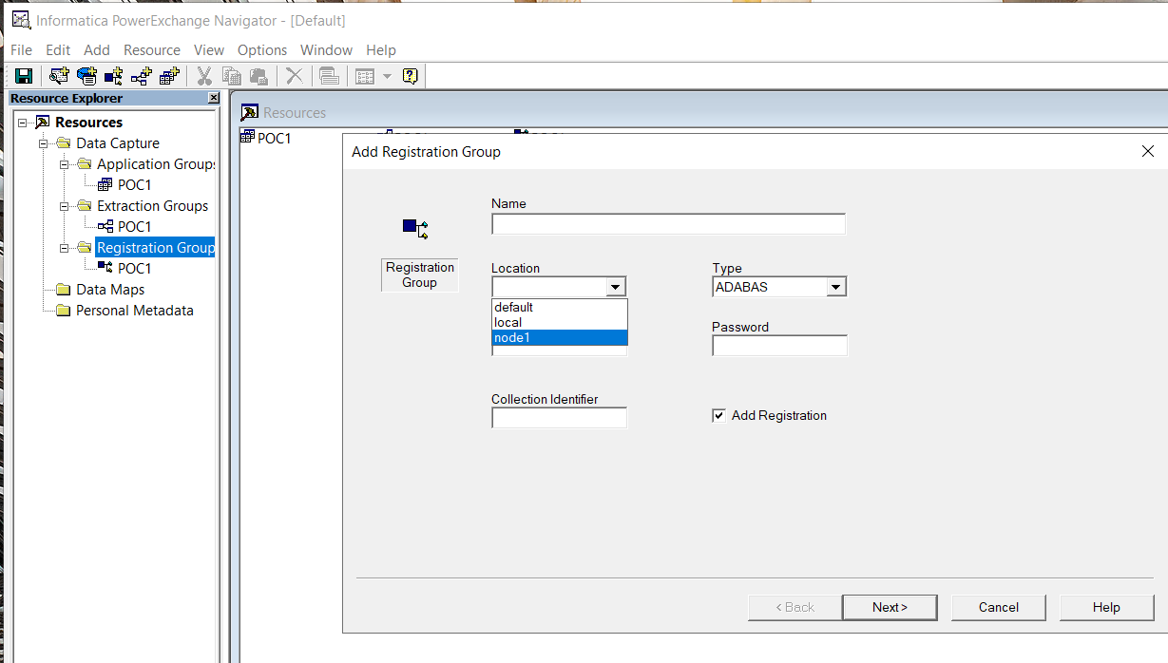

Location = Instance name in dbmover.cfg file

LISTENER=(node1,TCPIP,2480,262144,262144,262144,262144)
NODE=(local,TCPIP,127.0.0.1,2480)
NODE=(node1,TCPIP,127.0.0.1,2480,262144,262144,262144,262144)
NODE=(default,TCPIP,x,2480)

Type = MSSql

Use_id / PWD sa / corresponding pwd

Collection identifier
CAPI_CONNECTION=(NAME=CAPICAPX,TYPE=(CAPX,DFLTINST=PWX_00,FILEWAIT=60,RSTRADV=60,NOSEQVAL=N))

Add capture registration

Double click the registration group

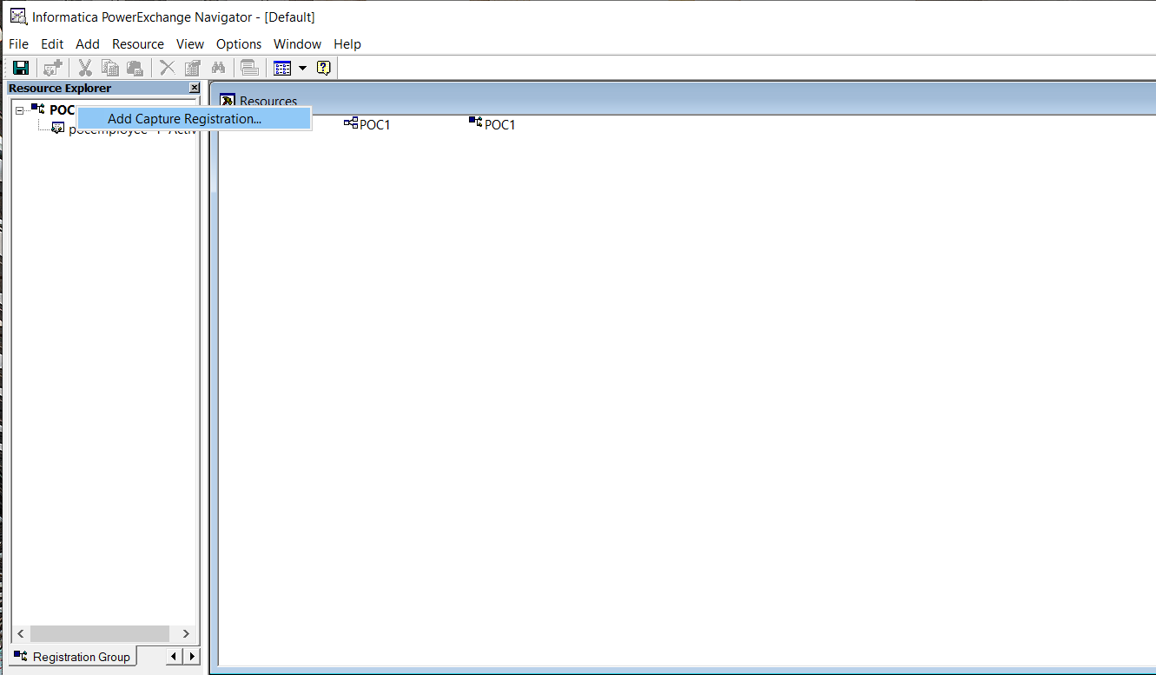

Give the capture registration name

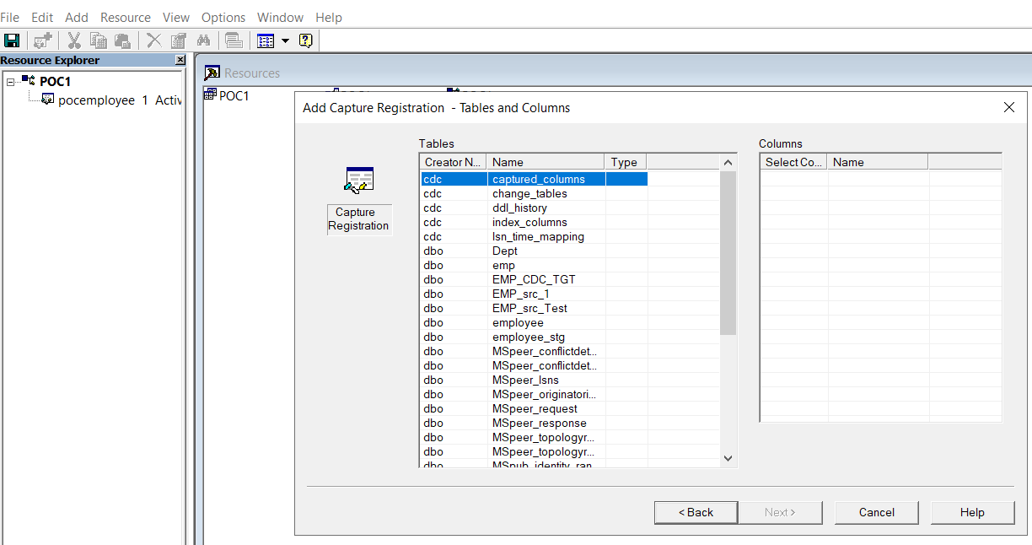

Select table with primary key

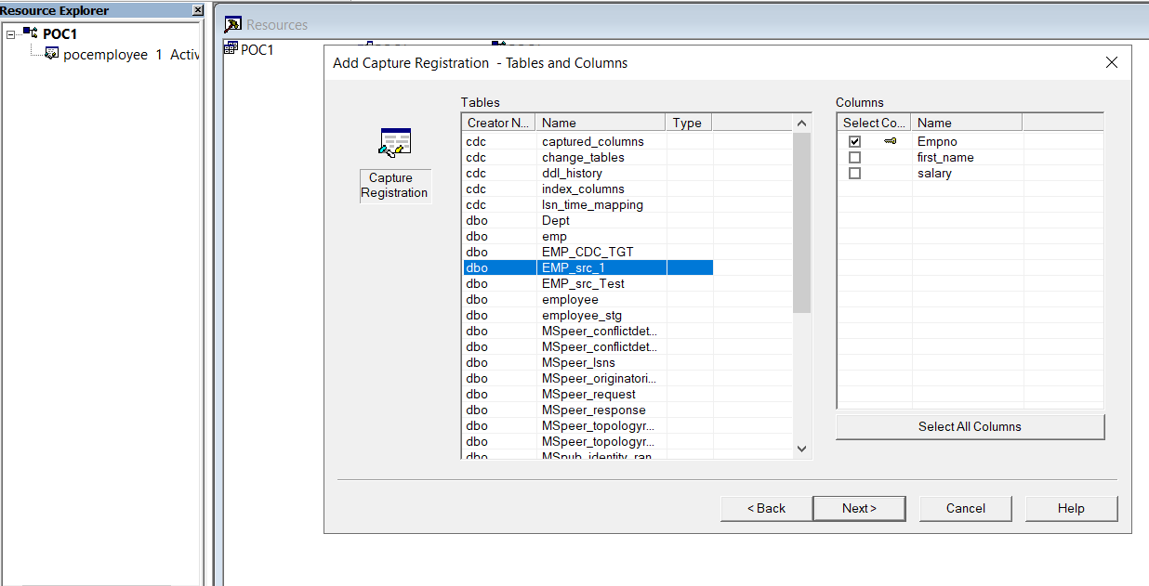

Select column name to be monitored

CDC Connection Configuration

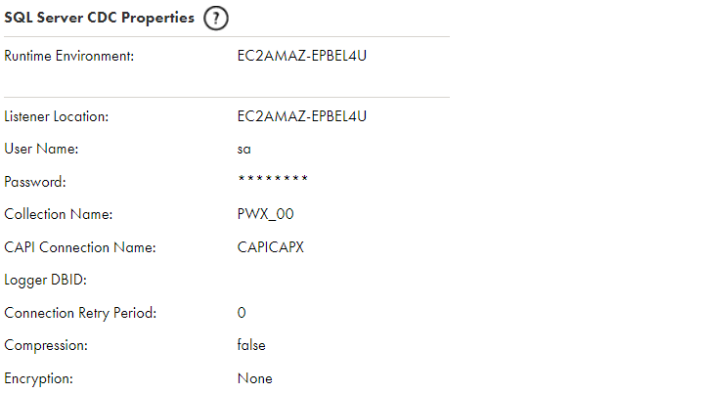

Listener Location = SQL server hostname ( Hostname : port EC2AMAZ-EPBEL4U :2480 )
User Name = db userID
Pwd : password of the db userID
Collection Name = ( refer to DFLTINST in the dbmover file)
Collection identifier
CAPI_CONNECTION=(NAME=CAPICAPX,TYPE=(CAPX,DFLTINST=PWX_00,FILEWAIT=60,RSTRADV=60,NOSEQVAL=N))

Build the Mapping

Create a mapping
Configure the source with CDC connection
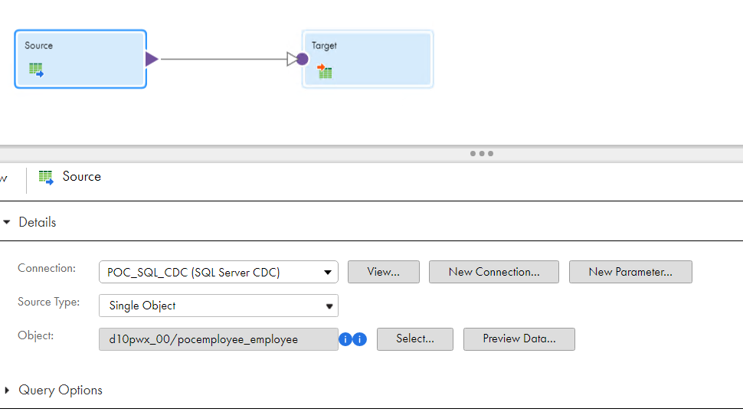
Select the CDC object that was configured through Navigator

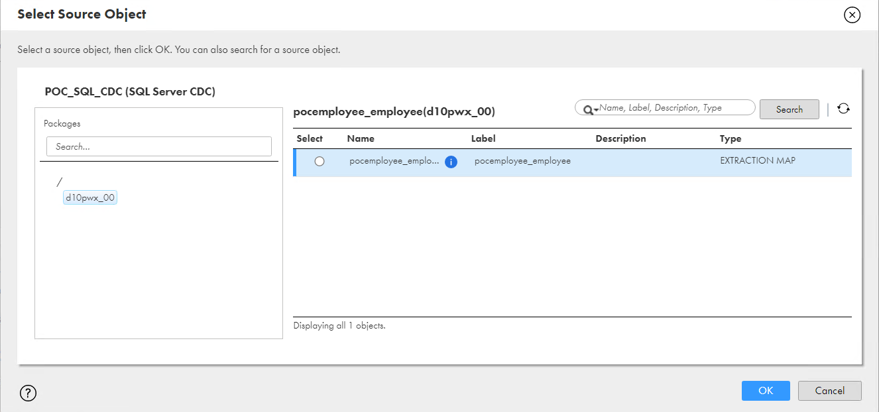

Configure the target as below

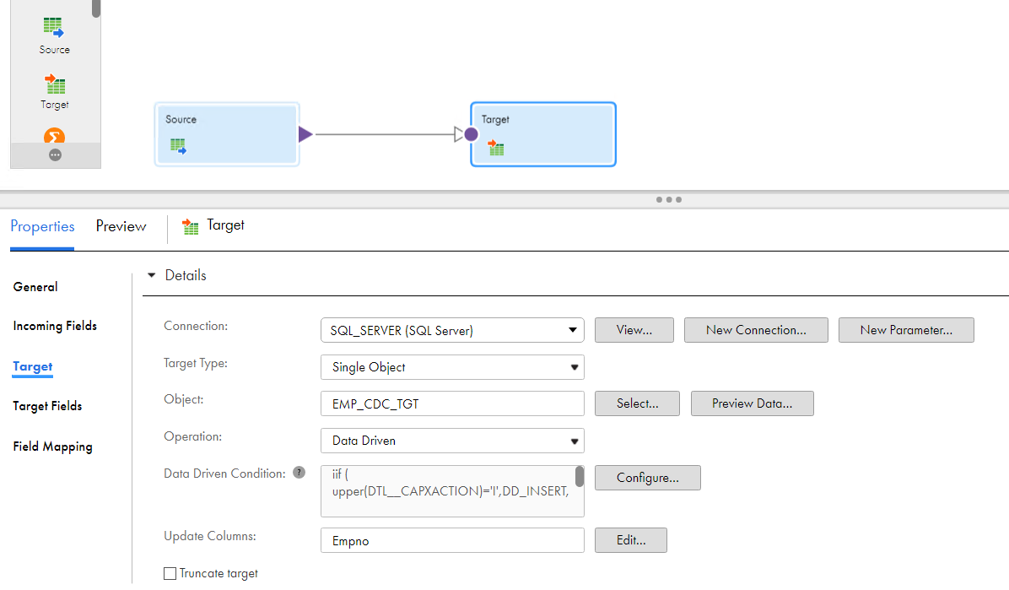

Data Driven configuration

iif ( upper(DTL__CAPXACTION)='I',DD_INSERT,

iif ( upper(DTL__CAPXACTION)='U',DD_UPDATE,DD_DELETE)

)

Configure the mapping task

